SECTION A
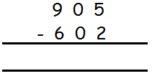  1. Subtract: | 2. Write 446 in words.
3. Work out:  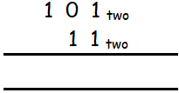 | 4. Simplify: ⁻7 - ⁻7
5. Work out: $\frac{1}{2}+\frac{1}{3}$ | 6. Solve: 4 – x = 7
7. The L.C.M of two numbers is 24 and their G.C.F is 4. If one of the numbers is 8, find the second number.

8. Round off 2.985 to the nearest whole number. | 9. Set R and T have common members. Draw a Venn diagram and shade (R$∩$T)¹
10. Given that 2^{n} = 64, find the value of n. | 11. Write CLIX in Hindu Arabic Numerals.
12. Mwanje had $\frac{2}{3}$ of an orange and gave $\frac{1}{2}$ of it to Nanteza. What fraction did he remain with?

13. Find the bearing of N from Z in the diagram below.
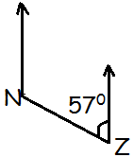

14. Find the perimeter of the figure below:
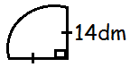

15. The pie chart below shows how Namusisi spends her monthly salary of 600,000/=. How much money does she spend on others?
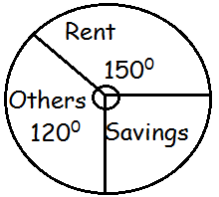

16. A mathematics test that was supposed to last for $2\frac{1}{2}$ hours ended at 1:07pm. What time did it begin?

17. Express 0.4545…….as a common fraction in its simplest form. | 18. The cost of 6 boxes of chalk is 18000/=. Find the cost of 4 similar boxes of chalk.
19. Using a ruler and a pair of compasses only, construct an angle of 75⁰ in the space below. | 20. Solve: 3 – 3x < 12.
SECTION B (60 MARKS)
21. The Venn diagram below shows the number of candidates who like Banana (B) and Mangoes (M). a) Find the value of x. (2mks)
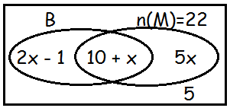

b) How many candidates like banana only? (2mks) | c) How many candidates were in the whole class? (2mks)
22. In the figure below PQ and SU are parallel lines. Angle PQR = 60⁰ and angle RPQ = 60⁰ and angle RPQ = 20⁰. Use it to answer the questions below:
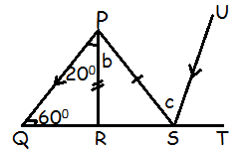
Find the size of angle b and c in degrees.
(4mks)

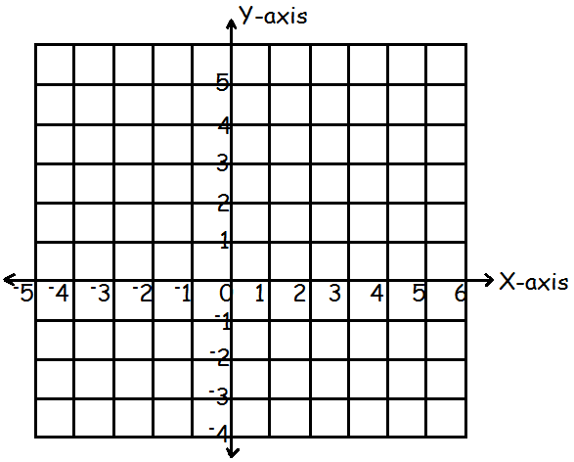
23(a) Plot the following points on the grid below: A(⁻1, 4), B(⁺5, ⁺4), C(⁺5, ⁺1) and D(⁻1, ⁺1).

b) Join the points A to B, B to C, C to D, and D to A and work out the area of the figure formed. (2mks)

24(a) Work out: $1\frac{1}{2} x\frac{1}{3} ÷\frac{1}{4}$ (2mks) | 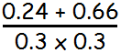  b) Work out: (3mks)
25(a) Solve for x: (3x – 4) – (x + 6) = 0. (2mks)

b) Ssentamu is three times as old as his son Kangave. In 5 years time their total age will be 46 years. How old is his son now? (3mks)

26. $\frac{1}{3}$ of the fruits in a basket are oranges, $\frac{2}{5}$ of the remainder are passion fruits and the rest of the fruits are guavas. If there are 20 guavas in the basket, how many fruits were in the basket altogether?

27. Musimenta went shopping and bought the following items:
Items | Quantity | Unit cost | Total
Rice | 3kg | Shs 3000Shs
Sugar | $2\frac{1}{2}$ kgShs |  | Shs 5000
Paraffin | litres | Shs 3600 | Shs 5400
Total |  |  | Shs
a) Complete the table above. (4mks)

b) If she used 2000/= for transport to and from the market, calculate her total expenditure. (2mks)

28. Two petrol tanks A and B can hold the same amount of petrol when filled up completely. (a) Find the amount of petrol tank A can hold in litres? (2mks)
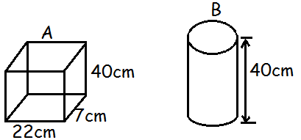

b) Find the diameter of tank B. (3mks)

29. The table below shows the scores of the pupils in a Mathematical test.
Scores | 4 | 5 | 6 |  | 9
No. of pupils | 4 |  | 13 | 8
Total marks | 16 | 45 |  | 56 | 45
a) Complete the table above. (4mks)

b) Find the range of the scores. (1mk)

30. A motorist drove at a steady speed of 90km/hr for 1 hour 30 minutes from A to town B. H ereturned at an average speed of 45km/hr.
a) How far is town A? (2mks) | b) Work out his average speed for the whole journey. (3mks)
31. Use the number line to answer the questions below.
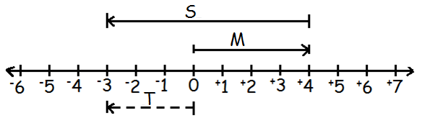

a) Find the integers shown by the arrows: (3mks)
i) S = ________________________ ii) M = _______________________
iii) T = ___________________________
b) Write a Mathematical statement represented by the above arrows on the diagram. (2mks)

32. Mugole left town K and drove eastwards to town B a distance of 36km. he then drove northwards from town B to village P a distance of 48km, and returned directly from P to town K.
a) Using a scale of 1cm to represent 6km, draw an accurate diagram to show Mugole’s journey. (3mks)

b) Find the shortest distance from town K to village P in km. (2mks)

*****GOD BLESS*****

